CLIENT NAME

JOB DESCRIPTION

INSPECTION REPORT

APPROVAL PAGE

Compiled By: | Name Surname | Signature | Date
Job Title
Afrinov (PTY) LTD
 |  |  | 10/00/2025

Checked By: | Name Surname | Signature | Date
Job Title
Afrinov (PTY) LTD
 |  |  | 10/00/2025

 | Approved By: | Name Surname |  |  | Signature | Date
Job Title
Afrinov (PTY) LTD
 |  |  |  |  |  | 10/00/2025

Table of Contents
APPROVAL PAGE 1
List of figures 3
1.0 introduction 4
2.0 FINDINGS OF THE INSPECTION 4
3.0 Recommendations 8
4.0 Conclusion 8

List of figures
Figure 1: The clamp grooves worn out & thinning at the top section 4
Figure 2: Grooves worn out 5
Figure 3: Turn Buckles installation issues. 5
Figure 4: Welded bracket not recommended. 6
Figure 5: Typical Bending Moments for Top Clamp 6
Figure 6: Bottom clamp cylinder 7

introduction
This report is based on the site visit to Samancor Ferro Metals on the 09th of July 2025. The client has assigned Afrinov with the task of inspection and examining the self-slip challenges they were experiencing on the bottom clamps in Furnace 5.

FINDINGS OF THE INSPECTION
During the inspection of the bottom clamps on Furnace 5:
- The one bottom clamp showed the complete wearing of the grooves that hold onto the casing at the upper section of the clamp compared to the bottom section of the clamp.
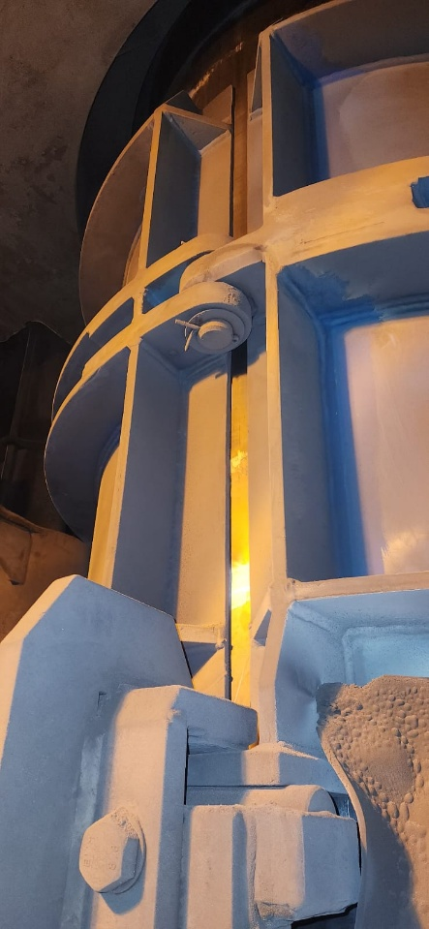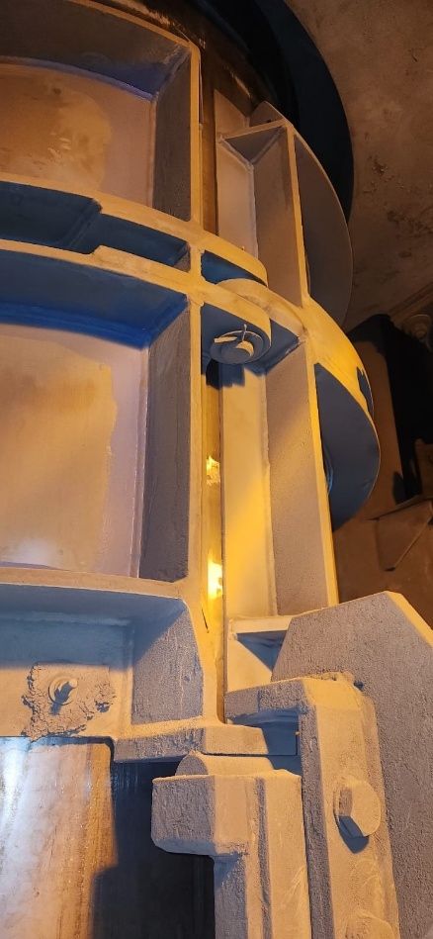
The casing shows abrasion patches on the casing at random places because of uneven clamping force.
Figure 1: The clamp grooves worn out & thinning at the top section

- The indication of the clamp grooves wearing off.
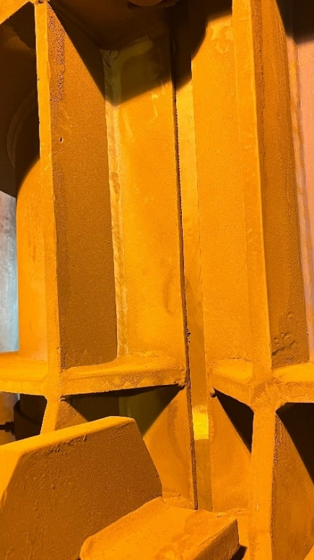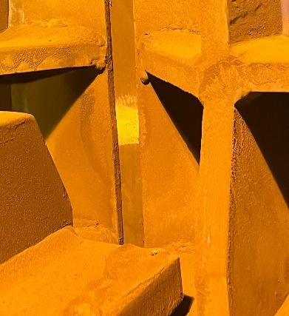
Grooves appearing to be worn out. This is another bottom clamp apart pictured, from Figure 1
Figure 2: Grooves worn out

- The current Turn Buckles installation has limits in adjusting the clamp to add more clamping force on the casing. This might be the reason why the clamping force is not enough, resulting in self-slip.
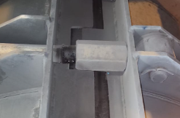
. 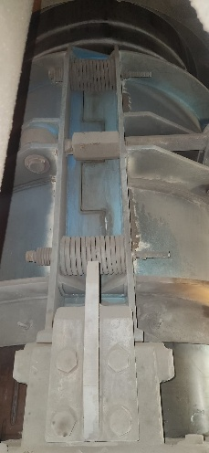 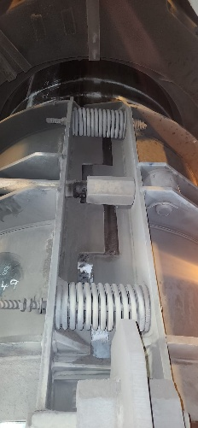
The turn buckles pressing on the clamp stiffener.
Figure 3: Turn Buckles installation issues.
- The bracket was welded post installation during maintenance. When welding the bracket, it changed the bending moment calculation of the clamp. This change had an effect on the cylinder force, and it is possible for causing problems. Though these forces can be rectified by applying more force through Turn Buckles.
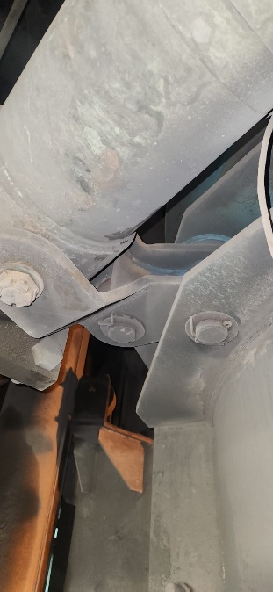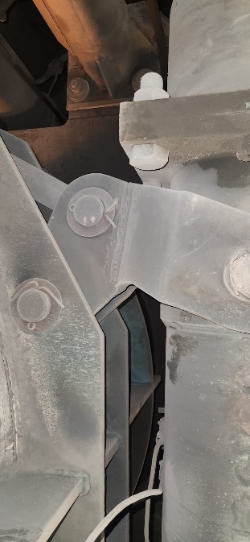
Figure 4: Welded bracket not recommended.

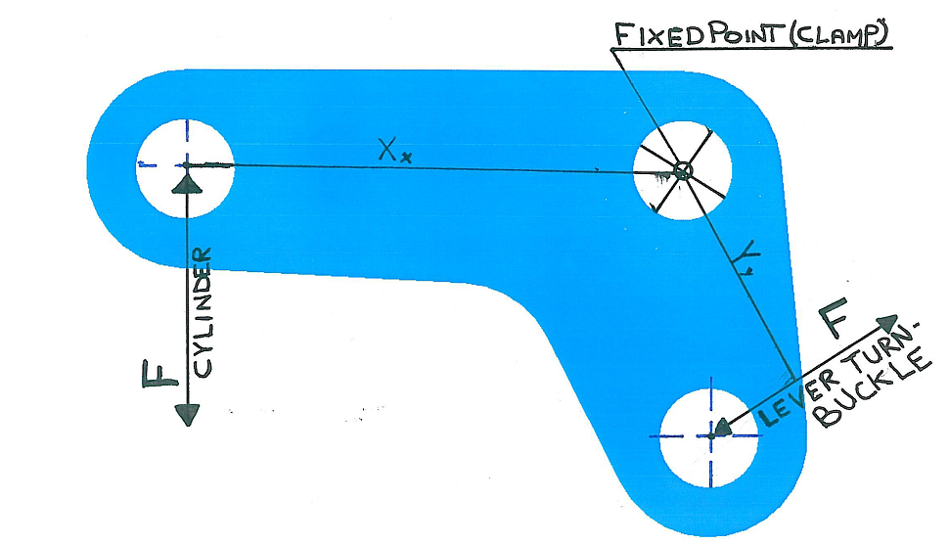
Figure 5: Typical Bending Moments for Top Clamp Bracket

- The cylinder settings are aligned to the requirements and current settings are correct as per required forces.
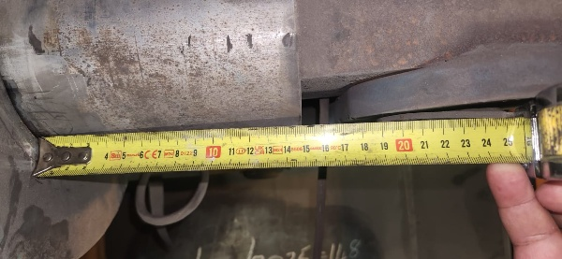
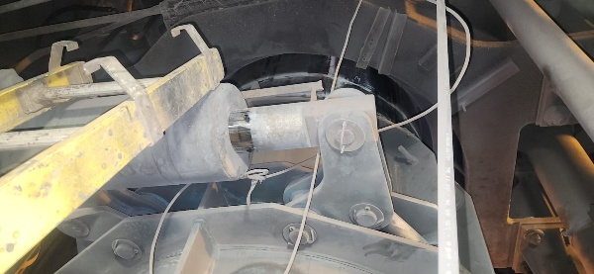
Figure 6: Bottom clamp cylinder

Recommendations
These are the recommendation to correct clamping device to acceptable standard:
- Change the clamp and correctly install the new clamping system.
- Remove the welded bracket as it's an operational risk and replace with unwelded bracket.
- Re-set the installation and correct the limitations on Turn Buckles to increase the clamping force.

Conclusion
The inspection revealed critical wear and mechanical inefficiencies in the bottom clamping system of Furnace 5, particularly due to worn grooves, improper turn buckle setup, and the use of welded brackets.
To restore structural integrity and ensure long-term reliability, the clamping system will undergo complete replacement, including clamp and bracket replacement, adjustment of the turn buckle system, and final testing before commissioning.
Replacing welded brackets with unwelded will enhance safety, ease of future maintenance due to welding failures, and reduce stress-related failures.

